Name | Yu-Lun Chang | 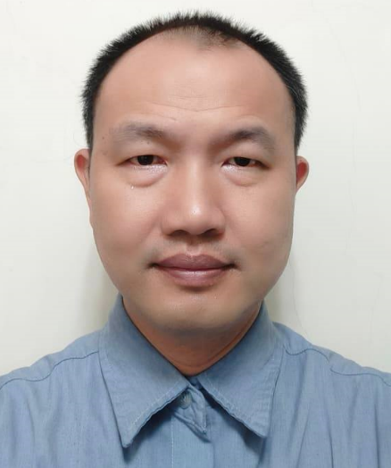
Title | Assistant Professor
Office | K203-4
Phone | 886-6-2533131 Ext. 3527
Email | yulun@stust.edu.tw
Webpage
Education | Ph.D., Mechanical Engineering, National Taiwan University of Science and Technology
Research Interests | Smart manufacturing, computer-aided drafting, computer-aided manufacturing, mechatronics, and industrial arm automation applications.
Laboratory

Publications
Journal Papers
- Y. L. Chang, C. Y. Lin, and J. H. Yang, "Cyber-physical-robotic System (CPRS)-based Modeling and Execution of Assembly Tasks", Sens. Mater. 30 (2018) 1919.
- C. Y. Lin, L. T. Son, Y. L. Chang, and Y. S. Shiue, "Image-Sensor-Based Fast Industrial-Robot Positioning System for Assembly Implementation", Sens. Mater. 29 (2017) 935.

Professional Certificates
- Technician Certificate of Class B in Computer Aided Engineering Drawing.
- Technician Certificate of Class B in Turning-CNC Turning.
- Technician Certificate of Class B in Machining, Computer Maintenance.
- Technician Certificate of Class B in Mechatronics.
- Technician Certificate of Class B in Digital Electronics.
- Technician Certificate of Class B in Machining.

