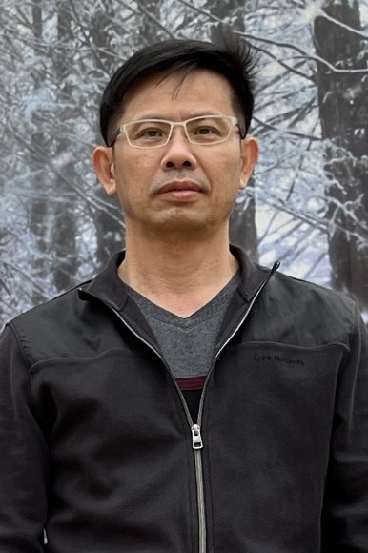 | 姓名：施銘賢 | 職稱：助理教授
 | 電話分機：3525 | 辦公室：K203-1
 | E-Mail：simonshih@stust.edu.tw
 | 實驗室：
最高學歷：國立成功大學工程科學博士
研究領域：熱流系統、電腦輔助設計、半導體封裝
學術榮譽
獲獎
期刊論文
- Chia-Wei Liang, Yu-Chi Sung, Ming-Hsiang Shih, Wen-Hsiang Liao, Te-Hsun Lin and Dong-Yan Yang, “Fan-Out Panel-Level Package Warpage and Reliability Analyses Considering the Fabrication Process”, Journal of Manufacturing Processes, Volume 119, 15 June 2024, Pages 649-665.
- K.F. YARN, M.C.HSIEH, M.H. SHIH, W.J. LUO, Y.H. KUO,C.N. CHEN, “ Performance enhancement of twin stack direct methanol fuel cells by coating active carbon catalyst on fuel channels ”, Digest Journal of Nanomaterials and Biostructures Vol. 9, No. 4, October – December 2014, p. 1417 – 1428.
- Win-Jet Luo, Kao-Feng Yarn, Ming-Hsyan Shih (2008, Nov). Microfluidic Mixing with Electrokinetic Instability Stirring by Electrical Field Intensity Perturbations. Proceedings of the 3rd IEEE Int. Conf. on Nano/Micro Engineered and Molecular Systems, pp 801-806.
- Win-Jet Luo, Kao-Feng Yarn, Ming-Hsyan Shih and Kuang Cheng Yu (2008, Nov). Microfluidic Mixing Utilizing Electrokinetic Instability Stirred by Electrical Field Intensity Perturbations in a Glass Microchannel. Optoelectronics and Advanced Materials – Rapid Communications, Vol. 2, No. 2, p. 117 - 125.
- Ming-Hsyan Shih and Win-Jet Luo (2008, May). Evaporation of non-Newtonian fluid in porous medium under mixed convection. Journal of Mechanics,, 24, 2, p.153-162.
- Win Jet Luo, Ming-Hsyan Shih, Kuo-Ching Chang and Ming-Hang Weng (2007, Nov). Microfluidic Mixing with Electrokinetic Instability Stirring by Electrical Field Intensity Perturbat. IEEE International Conference of Nano/Micro Engineered and Molecular Systems (IEEE-NEMS-2008).
- Ming-Hsyan Shih (2005, Apr). A study of the liquid evaporation with Darcian resistance effect on mixed convection in porous media. International communicational Heat and Mass Transfer, Vol.32, Issue 5, pp.685-694.
- Ming-Hsyan Shih (2004, Apr). Natural Convection Heat Transfer over a Horizontal Plate in Non-Newtonian Power Law Fluids. The Journal of the Chinese Society of Mechanical Engineers, Vol.25, No.2, pp.133-140.
- Ming-Hsyan Shih (2002, Apr). A Study of Liquid Evaporation on Forced Convection in Porous Media with Non-Darcy Effects. Acta Mechanica, Vol.154, pp.215-231.
- Ming-Hsyan Shih (2000,Aug.). A study of stress and wire-sweep under IC packaging, Journal of Mechanics , Vol.16, No.2,pp.93-100.
研討會論文
- 宋郁淇、梁家瑋、黃聖杰、施銘賢、廖文祥、林德勛, 考慮製程之面板及扇出型封裝翹曲與可靠度分析, 中國機械工程學會第 40 屆全國學術研討會, E5-006, 2023/12/1, 彰師大, 台灣
- W. J. Luo, K. F. Yarn, M. H. Shih, Y. L. Wu, K. C. Chang, and M. H. Weng, Microfluidic Mixing with Electrokinetic Instability Stirring by Electrical Field Intensity Perturbations, IEEE-NEMS 2008
- W. J. Luo, K. C. Chang, K. F. Yarn and M. H. Shih, (2007) “A Controller of Microfluidic Fraction Mixing Induced by DC and AC Electric Fields,” International Conference on Solid State Devices and Materials 2007, P-11-8, Japan.
- Ming-Hsyan Shih (2005, Aug). study of liquid evaporation on a flat plate in porous media with non-Newtonian fluid. 4th International Conference on Heat Transfer, Fluid Mechanics and Thermodynamics, Cairo, Egypt.
- Ming-Hsyan Shih (2004, May). A study of liquid evaporation on mixed convection in porous media with Non-Darcy effects. Military Academy 80th anniversary Comprehensive Symposium, Kaohsiung, Taiwan.
技術報告
專利
研究計畫
服務
- 2019/4~2024/7 群創光電 資深副理
- 2016/2~2019/4 裕榮昌科技有限公司 副研究員
- 2015/8~2016/6 銀泰科技 主任工程師
- 2004/8~2015/8 陸軍官校機械工程系 助理教授

