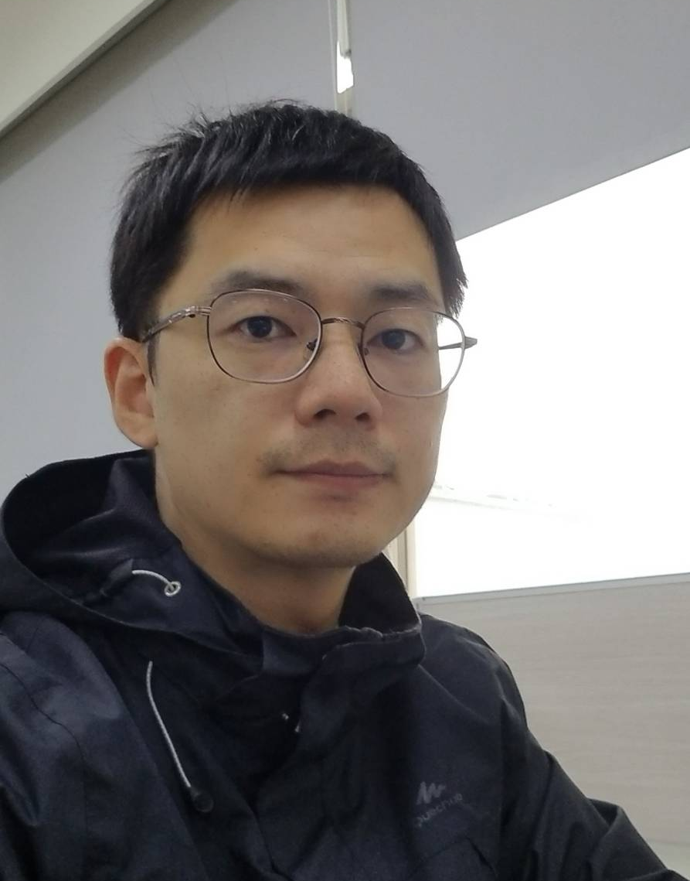 | 姓名：李訓源 | 職稱：助理教授
 | 電話分機：3553 | 辦公室：K315-1
 | E-Mail：hsunyuanli@stust.edu.tw
 | 實驗室：前瞻高分子製造與生醫感測實驗室
最高學歷：國立中正大學機械工程博士
研究領域：微奈米製程、生醫微機電系統、射出成型
學術榮譽
- 2018年臺綜大年輕學者創新研究優等獎
- 獲第十六屆國家新創獎，微流體光電整合敗血症快速診斷平台，謝文馨、趙文震、鄭宜肪、曾銘仁、張國恩、李訓源、李彥昌、賴俞杏。
- 獲第十七屆國家新創精進獎，微流體光電整合敗血症快速診斷平台，謝文馨、趙文震、鄭宜肪、曾銘仁、張國恩、李訓源、李彥昌、賴俞杏。
- 獲第十八屆國家新創精進獎，微流體光電整合敗血症快速診斷平台，謝文馨、趙文震、鄭宜肪、曾銘仁、張國恩、李訓源、李彥昌、賴俞杏。
- 獲第十九屆國家新創精進獎，微流體光電整合敗血症快速診斷平台，謝文馨、趙文震、鄭宜肪、曾銘仁、張國恩、李訓源、李彥昌、賴俞杏。
- 獲第二十一屆國家新創精進獎，微流體光電整合敗血症快速診斷平台，謝文馨、趙文震、鄭宜肪、曾銘仁、張國恩、李訓源、李彥昌、賴俞杏。

期刊論文
- Yu-Hsing Lai, Yan-Chang Lee, Hsun-Yuan Li and Wen-Hsin Hsieh* (2024, Feb). Dual-grating waveguide coupler biosensor for the real-time determination of human immunoglobulin M (IgM) antibodies.. Instrumentation Science & Technology.
- Yu-Hsing Lai, Yan-Chang Lee, Hsun-Yuan Li and Wen-Hsin Hsieh* (2024, Jan). 4-(Triethoxysilyl)butanoic acid as a self-assembled monolayer for surface modification of titanium dioxide.. Analyst. (IF=3.6)
- Yu-Hsing Lai, Hsun-Yuan Li, Wen-Hsin Hsieh (2022, Aug). Development of a label-free dual-grating waveguide coupler biosensor.. Sensors and Actuators, A: Physical. (IF=4.1)
- Chu-Tung Yeh, Devesh Barshilia, Chia-Jui Hsieh, Hsun-Yuan Li, Wen-Hsin Hsieh, and Guo-En Chang* (2021, Dec). Rapid and highly sensitive detection of C reaction protein using robust self-compensated guided-mode resonance biosensing system for point-of-care applications.. Biosensors. (IF=4.9)
- A-S.Yang, H-Y.Li, W-H.Hsieh, C-T.Kuo, Y-C. Yang (2016, May). A New Double-sided Grating Coupled Optical Sensor Using a Cross-Shaped Microchannel for Minimizing the Dispersion Effect . Chemical Engineering Journal . (IF=13.4)
- Ku, Yi-Fan; Li, Hsun-Yuan; Hsieh, Wen-Hsin; Chau, Lai-Kwan; Chang, Guo-En (2015, May). Enhanced sensitivity in injection-molded guided-mode-resonance sensors via low-index cavity layers . Optics Express . (IF=3.2)
- Hsun-Yuan Li, Wei-Chun Hsu, Kuan-Chi Liu, Yen-Liang Chen, Lai-Kwan Chau,Shuchen Hsieh, Wen-Hsin Hsieh (2015, Jan). A low cost, label-free biosensor based on a novel double-sided gratingwaveguide coupler with sub-surface cavities.. Sensors and Actuators B: Chemical, 206, 371-380. (IF=8). MOST 102-2120-M-194-001-CC2. 本人為第一作者.
- Hsun-Yuan Li, Chia-Wei Chen, Huang-Chin Yang, Lai-Kwan Chau, Wen-Hsin Hsieh (2011, May). Low cost, rapid fabrication of durable molds of grating arrays for nanoimprint lithography. Microelectronic Engineering, 88, 3062–3066. (IF=2.6). MOST 95-3114-P-194-001-MY3. 本人為第一作者.

國內期刊論文
- 謝文馨、李訓源、黃裕欽、程佳俊, “跨尺度奈米光學生物感測器之射出成型”, 微系統暨奈米科技協會月刊,2023/12
專利
- 張國恩、葉楚彤、陳沿菘、謝文馨、迪凡希、謝佳叡、李訓源, “具自我補償之高穩定度波導模擬共振式生物感測系統”, I805205, 中華民國, 發明專利, 2022/01
- Wen-Hsin Hsieh, Hsun-Yuan Li, Yan-Chang Lee, Yu-Hsing Lai, “BIOSENSING SYSTEM WITH SELF-COMPENSATION”, US 10,983,063 B2, 美國, 發明專利, 2021/03
- Wen-Hsin Hsieh, Yu-Hsing Lai, Hsun-Yuan Li, “DUAL GRATING SENSING SYSTEM, DUAL GRATING SENSOR AND DETECTING METHOD THEREOF”, US 10,884,193 B2, 美國, 發明專利, 2020/03
- 謝文馨、賴俞杏、李訓源, “雙光柵感測器、檢測方法及其製備方法”, I687687, 中華民國, 發明專利, 2020/03
- 謝文馨、李訓源、李彥昌、賴俞杏, “生物感測器自我補償系統”, I687676, 中華民國, 發明專利, 2020/03
- Wen-Hsin Hsieh, Lai-Kwan Chau, Hsun-Yuan Li, Wei-Chun Hsu,” DOUBLE-SIDED GRATING WAVEGUIDE BIOSENSOR”, US 9,140,857 B2, 美國, 發明專利, 2015/09

研究計畫
服務

