C:\Documents and Settings\PAPAYA\Local Settings\Temporary Internet Files\Content.IE5\Z8IYEHZ6\MC900423567[1].wmf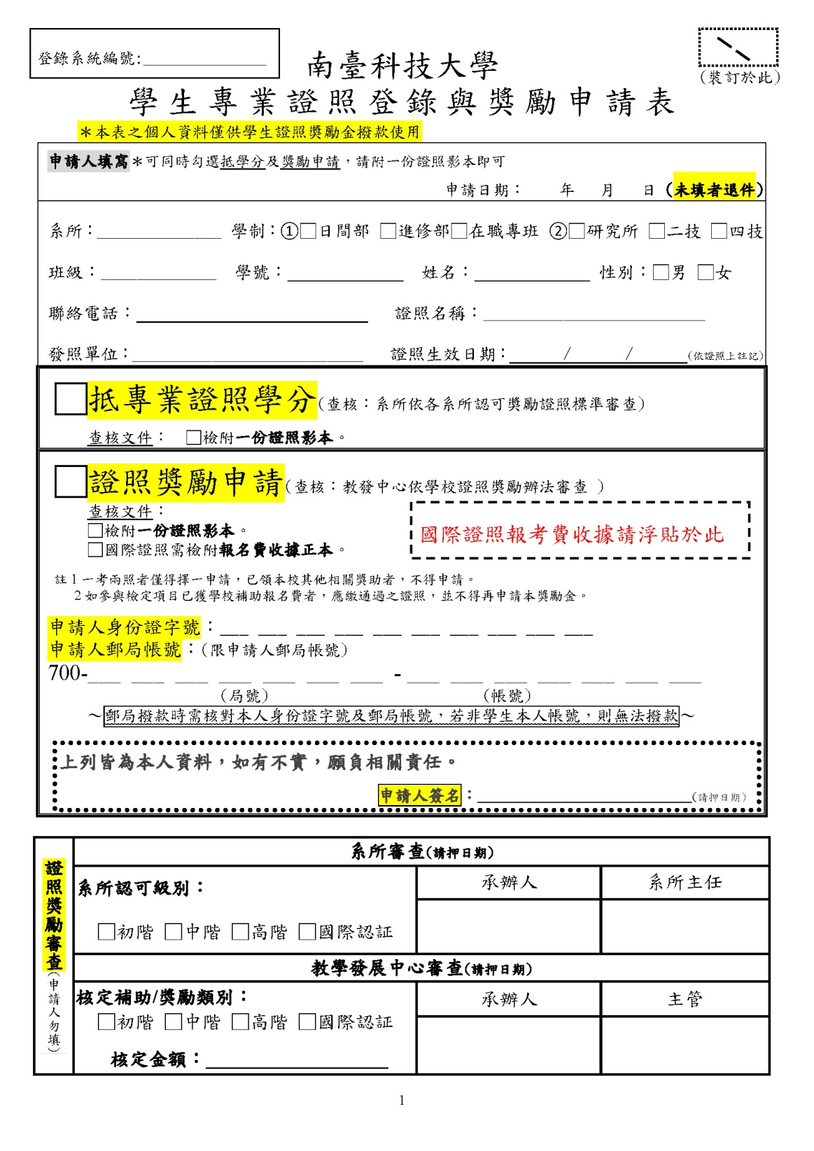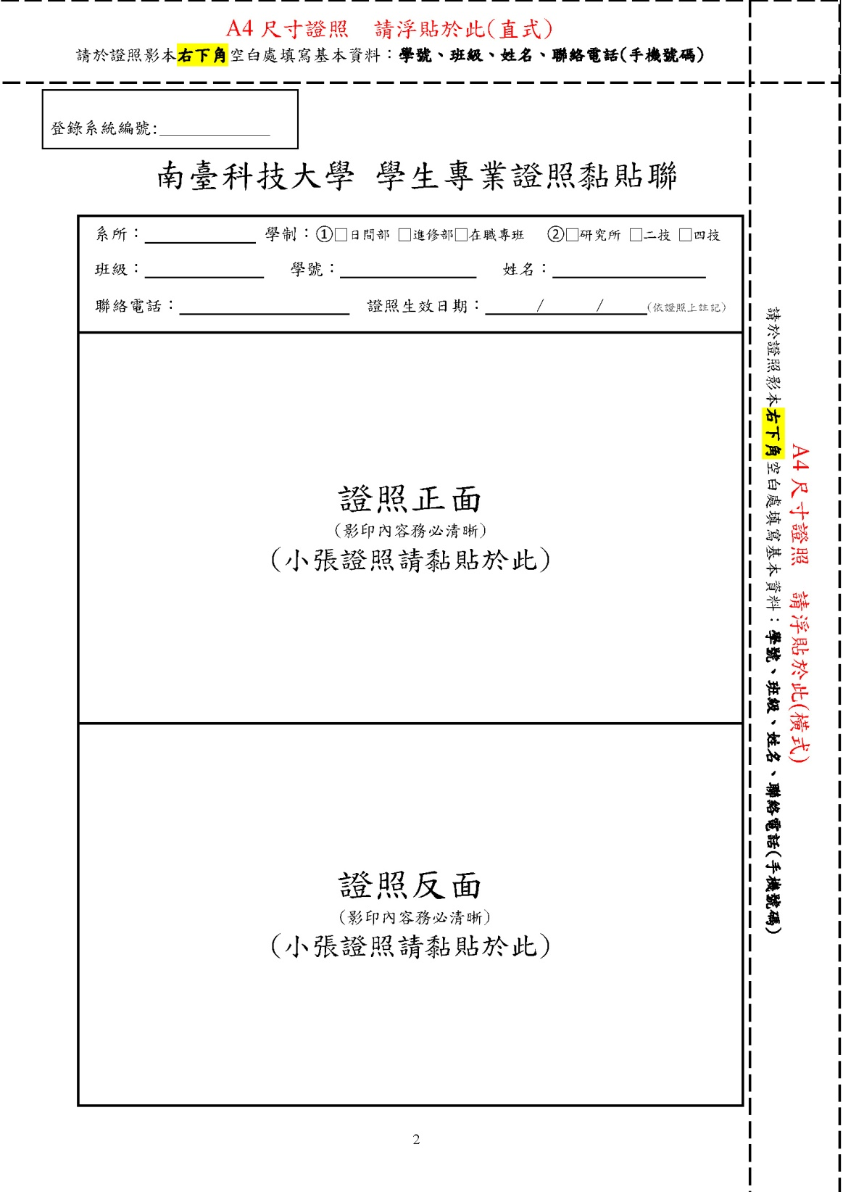

**自行黏貼證照影本**

**此兩格務必填寫及簽名**

**【範例】登錄表請至教學卓越計畫表格辦法下載**